Simple guide to using plickers
_________________________________

Download the Plickers app from the app store it is available an both apple and android
- Access the online live data at: www.plickers.com

How to use the website
- The Website is fairly easy to use, once you have created a log in you are directed to create your own classroom. This will consist of all the pupils. Each pupil will be assigned a number that corresponds to tie plickers code.

- After you have added all your class they will all be assigned a number that links to their plickers code. You can add up to 40 students! (Make sure you label the Plicker cards so they don’t get lost.)
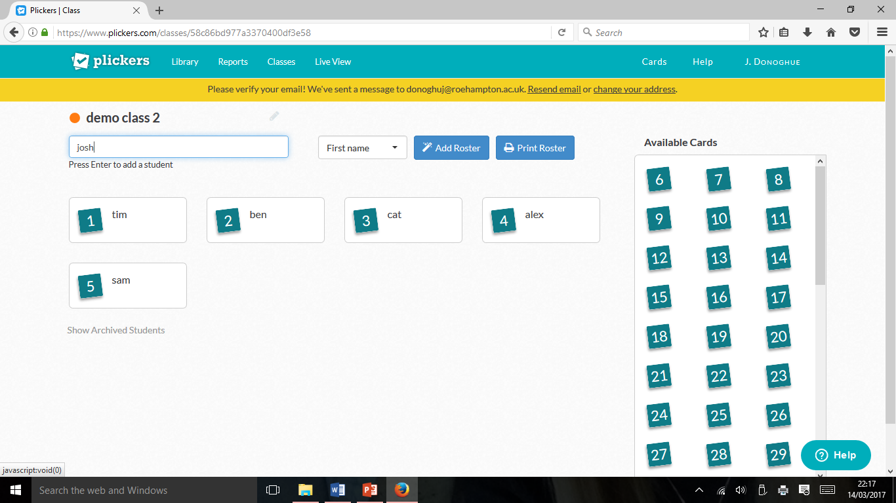

- After you have set up the class, you can start adding questions to your classroom. To do this simply press the drop down button and then add the question to the que, and select the class you want to add it too.
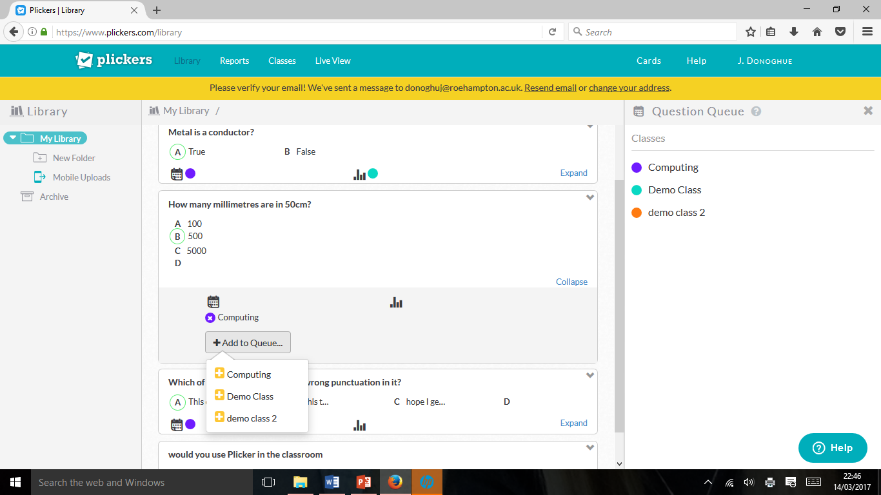

- Once you have selected the questions, switch to your mobile device and press scan, it will open up your camera to scan the QR codes.

- This is what your screen will look like as you do this (on the computer) as the codes are scanned the results will appear and you can compare and discuss results.

